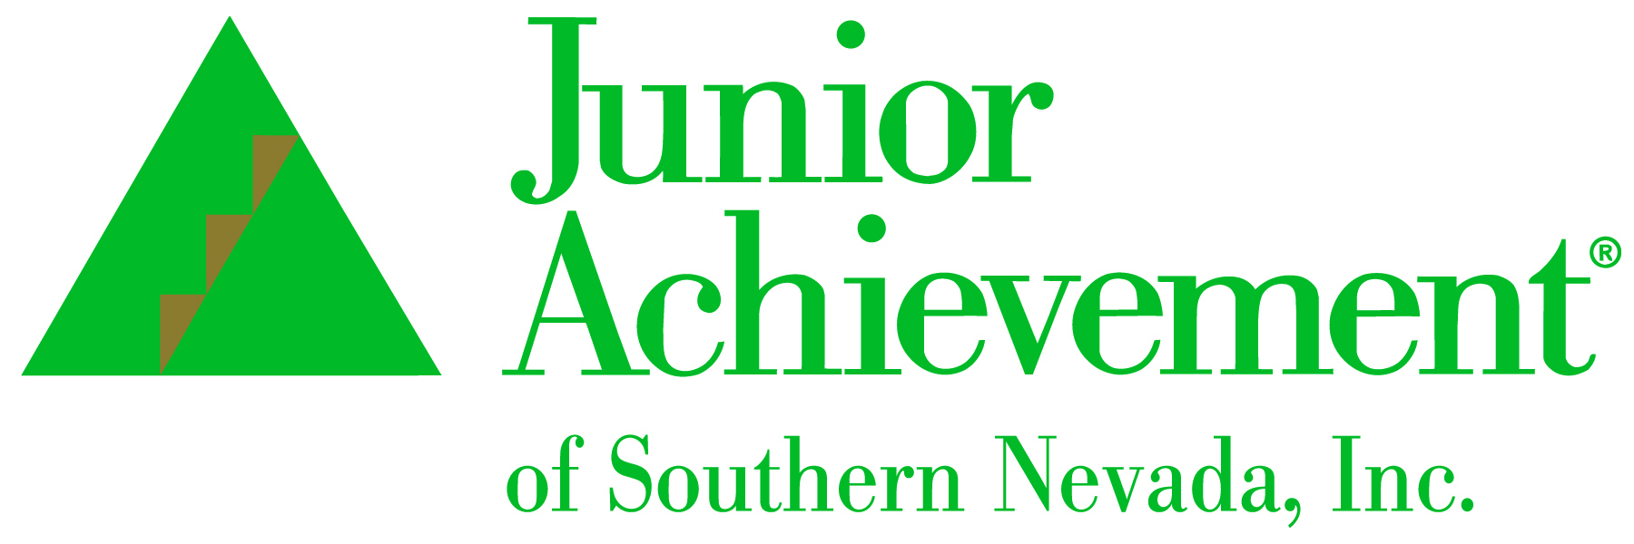
NEWS RELEASE
For Immediate Release

For More Information, Contact:
Michelle Jackson, President
Junior Achievement of Southern Nevada, Inc.
702-214-0503
michelle.jackson@ja.org

Junior Achievement of Southern Nevada Announces New Board Member
Hilary Nelson of Lexicon Bank



LAS VEGAS, NV – Junior Achievement of Southern Nevada is proud to announce Hilary Nelson has joined its board of directors.
As Lexicon Bank’s senior vice president of operations and compliance, Nelson is responsible for leading and overseeing its compliance, Bank Secrecy Act (BSA) and Anti-Money Laundering (AML) operations. Her focus ensures continuity among all areas of the bank regarding policies and procedures, along with the development, creation, and implementation of special projects. Additionally, she manages and coordinates all federal and state examinations and audits.
“We are so excited to have Hilary as part of our board leadership team. Her passion for Junior Achievement’s mission is tried and true as shown through her personal volunteer time, and her experience and efforts in helping the community will be a great assets to our board," said Michelle Jackson, president of Junior Achievement of Southern Nevada.
Nelson was born and raised in Southern Nevada and attended and graduated from Rancho High School. She has a bachelor’s degree in business management from Western Governors University in Salt Lake City, an advanced certificate in Compliance by the American Bankers Association, and a Regulatory Compliance Management Certificate with The American Institute of Banking.
“Our community's children need as much support as they can get. Junior Achievement of Southern Nevada provides needed help with financial literacy in a way that kids learn how to fish versus just being given fish," said Nelson. "I appreciate JA's work to educate and support youth and its Southern Nevada focus, and look forward to continuing and growing its efforts."

About Junior Achievement of Southern Nevada
Junior Achievement of Southern Nevada, Inc. was founded locally in 1996. The organization is dedicated to providing financial education to students K-12, with a curriculum that spans from budget management to economic principals, workforce skills and credit. Junior Achievement of Southern Nevada reaches more than 20,000 students annually in the Las Vegas area with the help of 285 businesses and 6,800 business role models. For more information visit https://jasnv.org/ and follow on Instagram and Facebook.

About Junior Achievement USA® (JA)
Junior Achievement is the world's largest organization dedicated to giving young people the knowledge and skills they need to own their economic success, plan for their future, and make smart academic and economic choices. JA programs are delivered by corporate and community volunteers, and provide relevant, hands-on experiences that give students from kindergarten through high school knowledge and skills in financial literacy, work readiness and entrepreneurship. Today, JA reaches 4.5 million students per year in 115 markets across the United States, with an additional 5.8 million students served by operations in 120 other countries worldwide. Visit www.ja.org for more information.
# # #

